

NOTRE DAME UNIVERSITY
BANGLADESH
CSE LAB Report-01
Submitted by:
Name: Istiak Alam
ID: 0692230005101005
Batch: CSE-20
Date: 15-07-23
Course Title: Data Structure Lab
Course Code: CSE-2104
Lab Task Topic: Array print, Index, Sum, Average, Intersection.

Submitted To:
Humayara Binte Rashid
Lecturer, NDUB

Problem No. 01
Name of the problem: Write a program in C to store N numbers of elements in an array and print it.

Solution:
//Lab Task 1 Question no. 1
//print array numbers
#include<stdio.h>
int main()
{
printf("Enter no. of elements: ");
int n,i;
scanf("%d",&n);
int a[n];
for(i=0;i<n;i++)
scanf("%d",&a[i]);
printf("\nArray is:\n");
for(i=0;i<n;i++)
printf("\ta[%d]=%d\n",i,a[i]);
return 0;
}

Output:
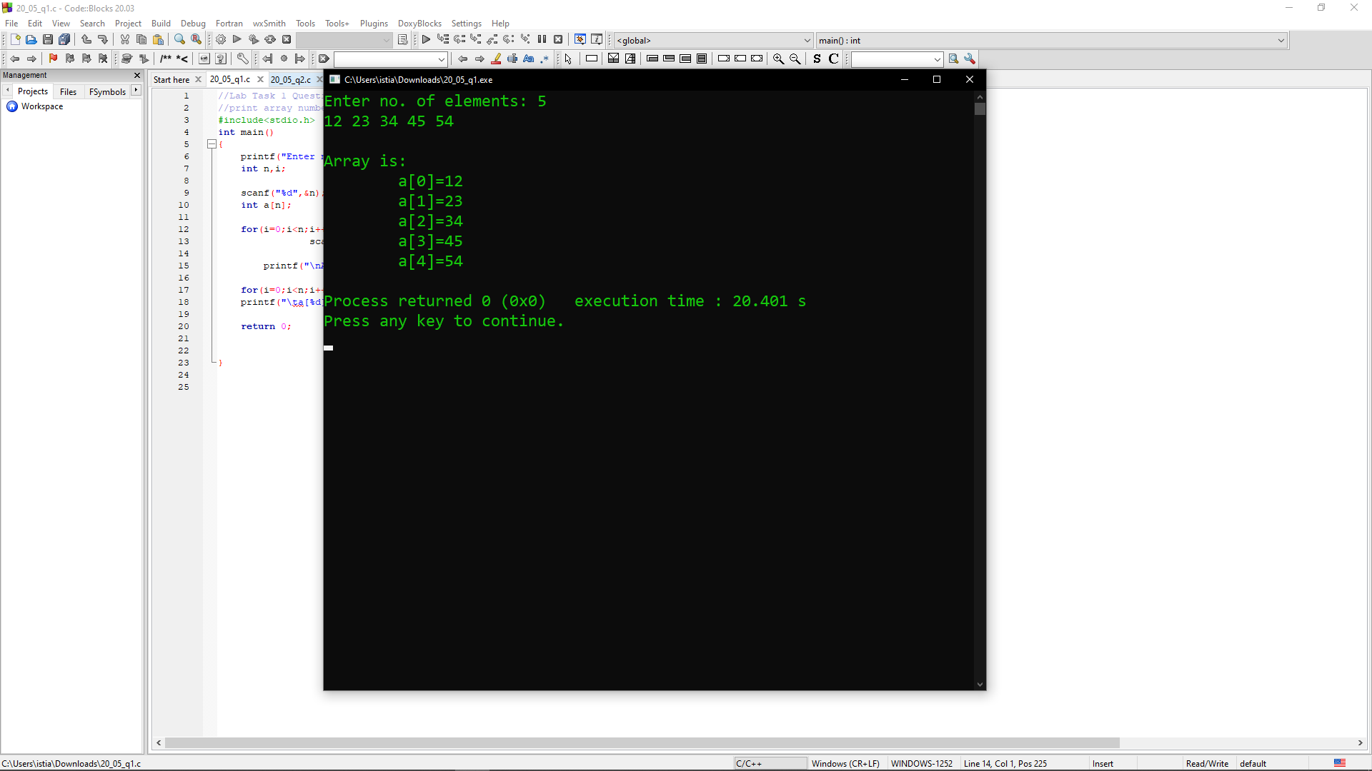

Problem No. 02
Name of the problem: Write a program in C to find out the even values of an array.

Solution:
//Lab Task 1 Question no. 2
//Find out the even values of an array
#include<stdio.h>
int main()
{
printf("Enter no. of elements: ");
int n,i;
scanf("%d",&n);
int a[n];
for(i=0; i<n; i++)
scanf("%d",&a[i]);
printf("\nArray is: \n");
for(i=0;i<n;i++){
if(a[i]%2==0)
printf("\tA[%d]=%d\n",i,a[i]);
}
return 0;
}
Output:
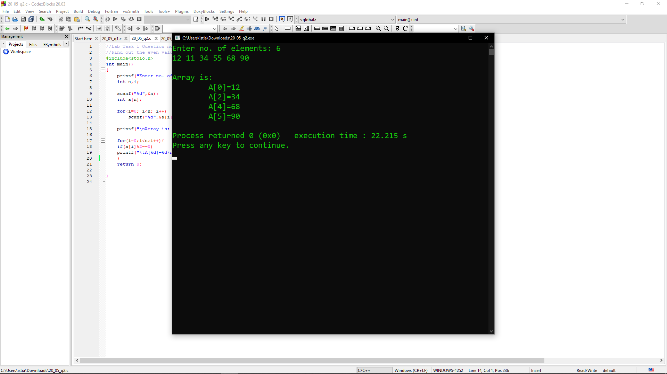

Problem No. 03
Name of the problem: Write a program in C to find out the values of the odd indexes of N numbers of elements of an array.

Solution:
//Lab Task 1 Question no. 3
//find out the values of the odd indexes
#include<stdio.h>
int main()
{
printf("Enter no. of elements: ");
int n,i;
scanf("%d",&n);
int a[n];
for(i=0;i<n;i++)
scanf("%d",&a[i]);
printf("\nArray is: \n");
for(i=0;i<n;i++){
if(i%2!=0)
printf("\tA[%d]=%d\n\n",i,a[i]);
}
return 0;
}
Output:
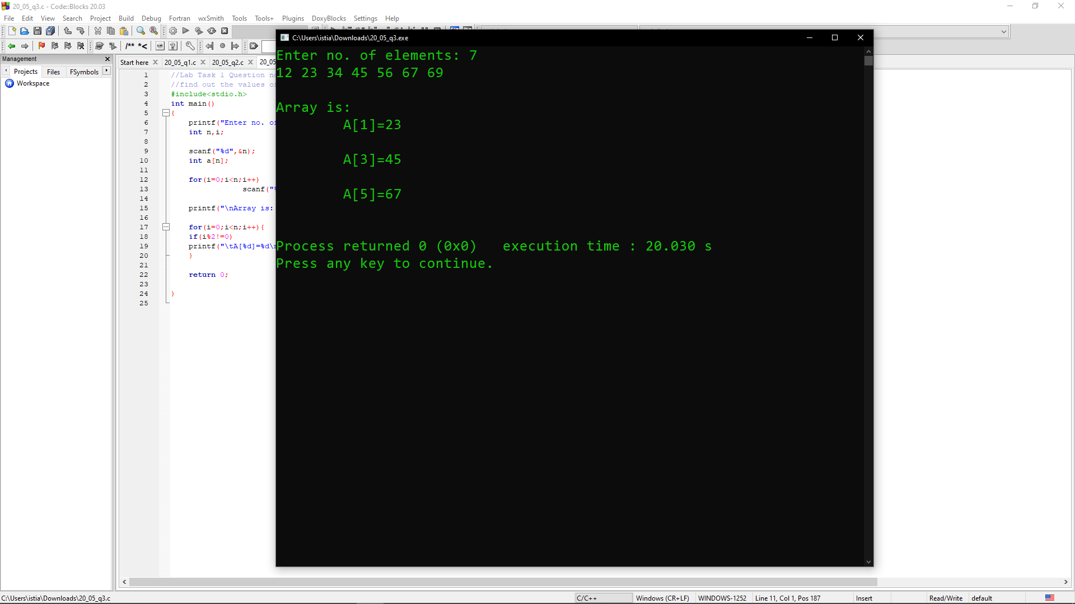

Problem No. 04
Name of the problem: Write a program in C to find the sum of all elements of the array of N elements.

Solution:
//Lab Task 1 Question no. 4
//find the sum of all elements
#include<stdio.h>
int main()
{
printf("Enter no. of elements: ");
int n,i;
scanf("%d",&n);
float a[n],sum=0.0;
for(i=0; i<n; i++)
scanf("%f",&a[i]);
for(i=0; i<n; i++)
{
sum=a[i]+sum;
}
printf("\nSum of %d elements is %f",n,sum);
return 0;
}
Output:
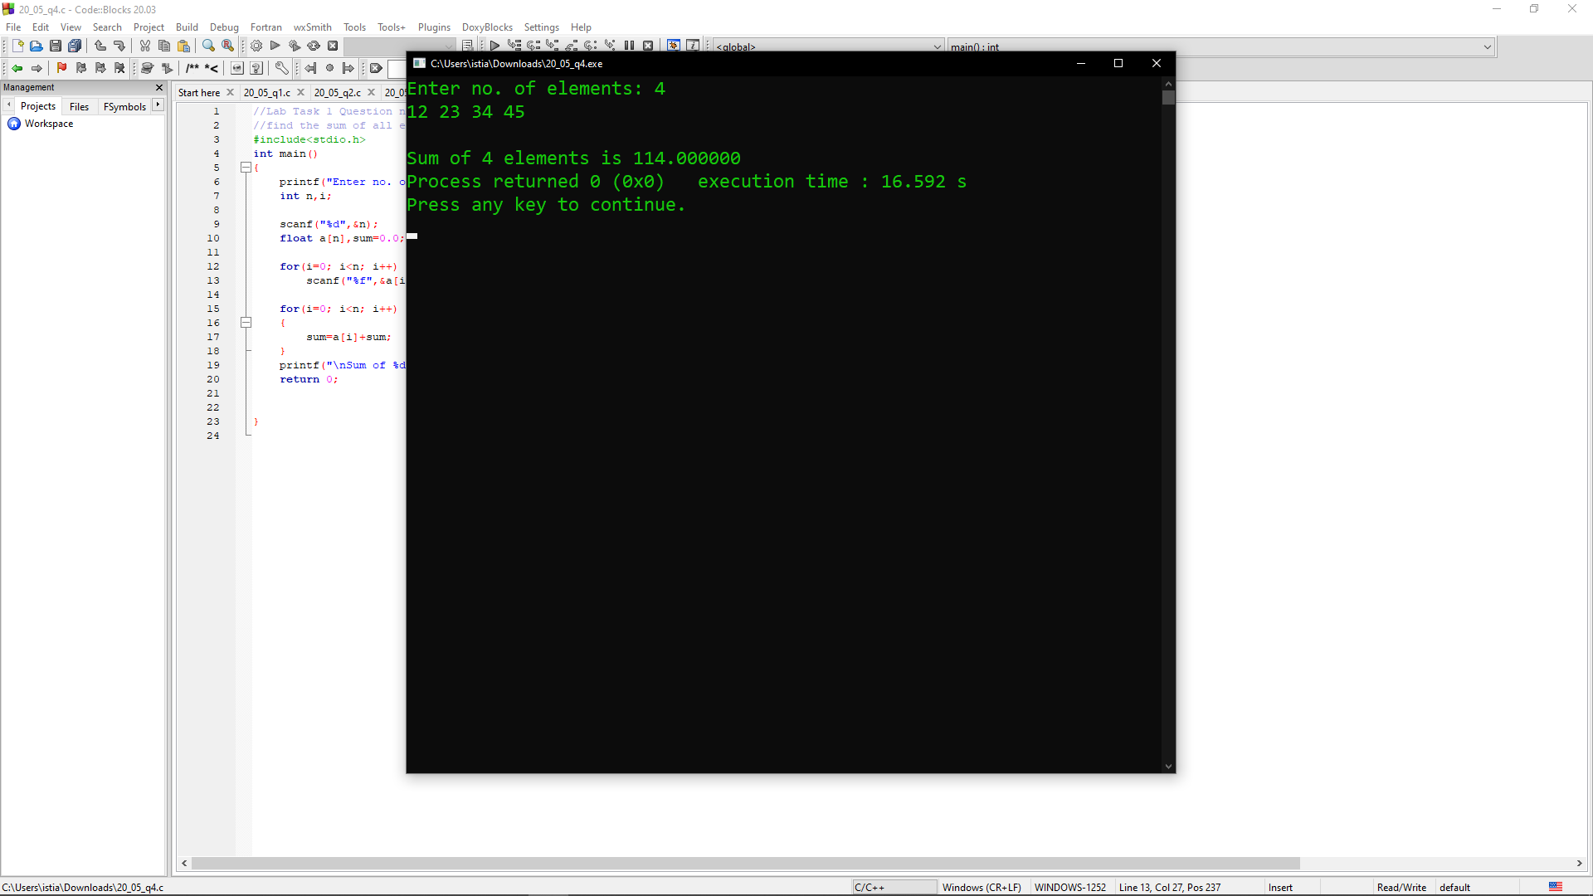

Problem No. 05
Name of the problem: Write a program in C to find the average of all elements of the array.

Solution:
//Lab Task 1 Question no. 5
//find the average of all elements
#include<stdio.h>
int main()
{
printf("Enter no. of elements: ");
int n,i;
scanf("%d",&n);
float a[n],sum=0.0,avg;
for(i=0; i<n; i++)
scanf("%f",&a[i]);
for(i=0; i<n; i++)
{
sum=a[i]+sum;
}
avg=sum/n;
printf("\nAverage of %d elements is %f",n,avg);
return 0;}
Output:
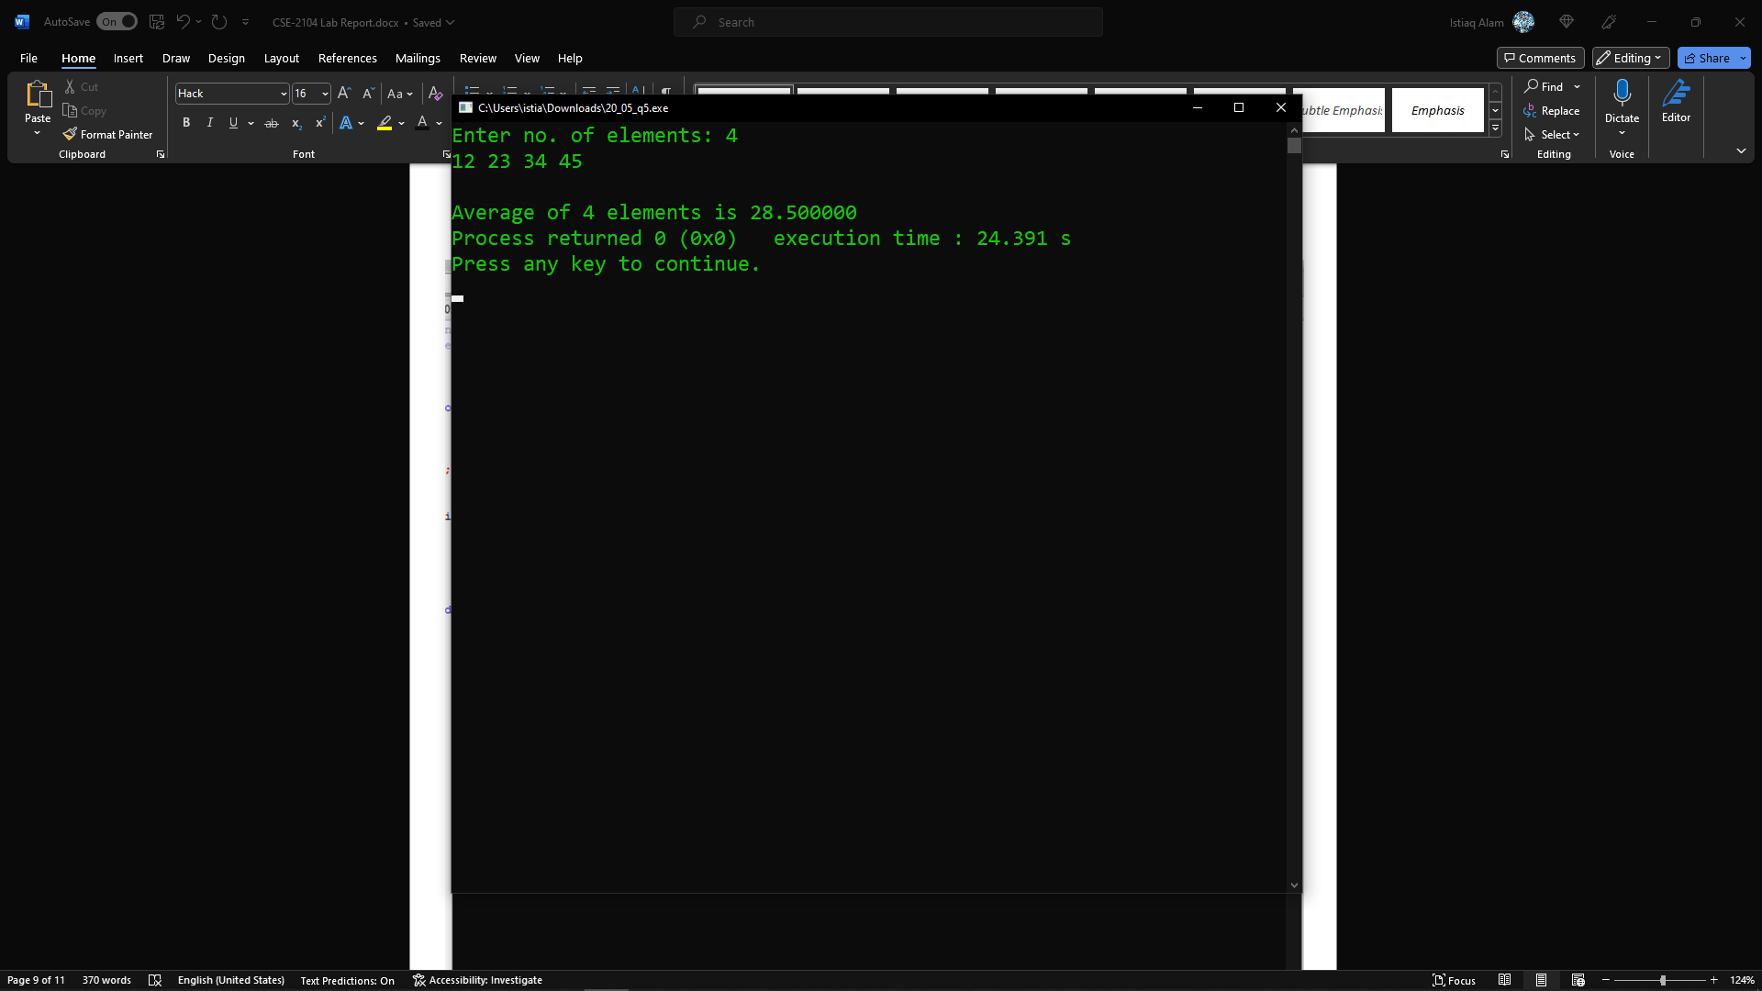

Problem No. 06
Name of the problem: Find out the intersection values of 2 arrays.

Solution:
//Lab Task 1 Question no. 6
//intersection values of 2 arrays.
#include<stdio.h>
int main()
{
printf("Enter no. of elements of A: ");
int n,i,m,j;
scanf("%d",&n);
int A[n];
for(i=0; i<n; i++)
scanf("%d",&A[i]);
printf("Enter no. of elements of B: ");
scanf("%d",&m);
int B[m];
for(i=0; i<m; i++)
scanf("%d",&B[i]);
printf("Intersection : ");
for(i=0; i<n; i++)
{
for(j=0; j<m; j++)
{
if(A[i]==B[j])
printf("%d ",A[i]);
break;
}
}
return 0;
}

Output:
